|  |  |
| --- | --- |
| ABS SYSTEM Name: NAVEEN KUMAR REmployee Id: 214971 |  |

**Anti-Lock Braking System (ABS)**

The Anti-Lock Braking System (ABS) comes as a safety feature in all the modern cars. ABS operates by preventing the wheels from locking up during braking, thereby maintaining tractive contact with the road surface and allowing the driver to maintain more control over the vehicle.

ABS is part of an overall stability system, commonly known as electronic stability control, which monitors wheels under heavy braking. Each wheel has a sensor attached to it. If the intelligent sensors detect that a wheel is about to lock up and stop moving, the system will release the brake. The release is only for a moment. ABS then continuously and repeatedly applies optimum braking pressure to each wheel, meaning the system will brake just enough to not lock the wheels.

**Modeling in Simulink**

In the project, an ABS system has been modeled using basic simulink blocks. Here, the vehicle is assumed to be moving along a smooth road with an initial velocity. The start of simulation indicates the application of brakes for stopping the vehicle. We assume hard braking conditions which may result in the vehicle wheel getting locked. This is an undesirable scenario as locking up of wheels causes the wheels to slide and results in accidents. An ABS system prevents this locking up of wheels by applying braking pressure slowly but steadily which facilitates the wheels to roll through and come to a halt.

The vehicle wheel rotates with an initial angular speed that corresponds to the vehicle speed. The start of simulation indicates the application of brakes.

Now, Slip is defined as :

Slip = 1 – (wheel angular velocity / vehicle angular velocity)

A value of zero slip indicates that both wheel and vehicle angular velocities are equal meaning perfect rolling of wheel on the road and the brakes are not yet applied.

On the other hand a slip value of 1 indicates zero wheel angular velocity which means the vehicle is sliding on the road and the wheels are locked. A desirable slip value is 0.2, which means that the number of wheel revolutions equals 0.8 times the number of revolutions under non-braking conditions with the same vehicle velocity. This maximizes the adhesion between the tire and road and minimizes the stopping distance with the available friction.

**Modeling- Key Points**

1). The coefficient of friction **Mu** is an **empirical function of slip**. It is known as Mu-Slip curve. A **1D Look Up Table** has been used to map the slip values to the corresponding Mu values.

2). The model multiplies the friction coefficient, mu, by the weight on the wheel, W, to yield the **frictional force, Ff**, acting on the circumference of the tire. Ff is divided by the vehicle mass to produce the vehicle deceleration, which the model integrates to obtain vehicle velocity.

3). From the Mu-Slip curve it has been observed that **a slip value** of **0.2** is ideal under braking conditions as the Mu value is highest around that value which helps in having more tractive contact with the road. SO a desired value of 0.2 is set. The difference between the actual slip and desired slip is calculated as error, which is then provided to a **bang-bang controller**.

4). To control the rate of change of brake pressure, the model **subtracts actual slip from the desired slip** and feeds this signal into a bang-bang control (+1 or -1, depending on the sign of the error). This on/off rate passes through a **first-order lag** that represents the delay associated with the hydraulic lines of the brake system. The model then integrates the filtered rate to yield the actual brake pressure. The resulting signal, multiplied by the piston area and radius with respect to the wheel (Kf), is the **brake torque** applied to the wheel.

5). The model multiplies the frictional force on the wheel by the wheel radius (Rr) to give the accelerating torque of the road surface on the wheel. The brake torque is subtracted to give the net torque on the wheel. Dividing the net torque by the wheel rotational inertia, I, yields the wheel acceleration, which is then integrated to provide wheel velocity. In order to keep the wheel speed and vehicle speed positive, limited integrators are used in this model

6). The actual slip of the wheel is then calculated from the equation,

Slip = 1 – (wheel angular velocity / vehicle angular velocity).

A **MATLAB Function block** has been used for this purpose.

7). The system is then simulated with a stop time of 25 seconds and an initial velocity of 35Kmph. The actual slip, wheel speed and vehicle speed are then viewed using the simulation data inspector.

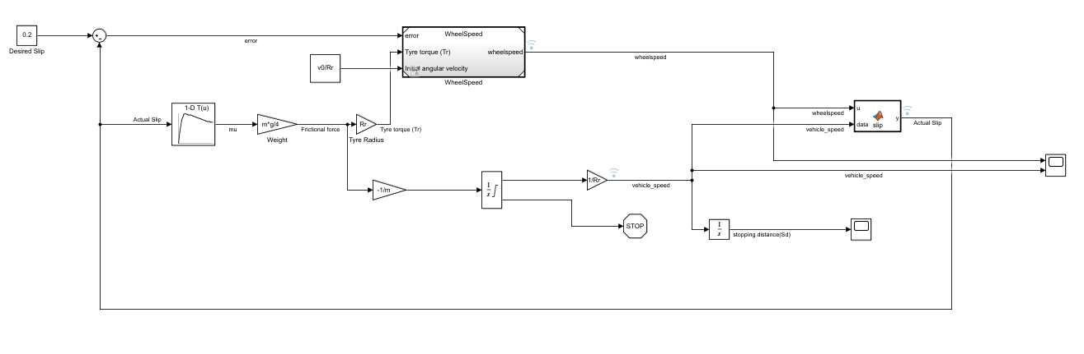

Figure : Simulink Model of ABS System

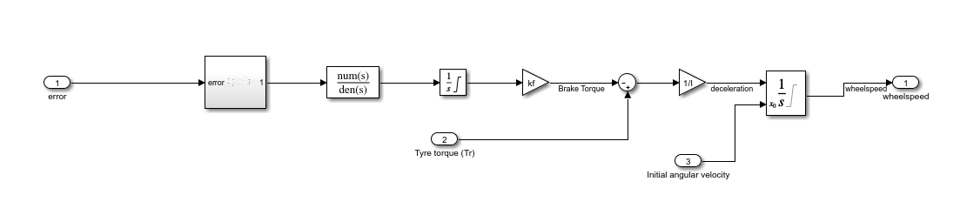

Figure : Wheelspeed referenced model

**1D Look Up Table**

A 1D LookUp table has been used to map the slip values with coeeficient of friction (Mu) values.

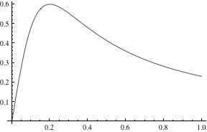

Figure 1: Mu-slip curve

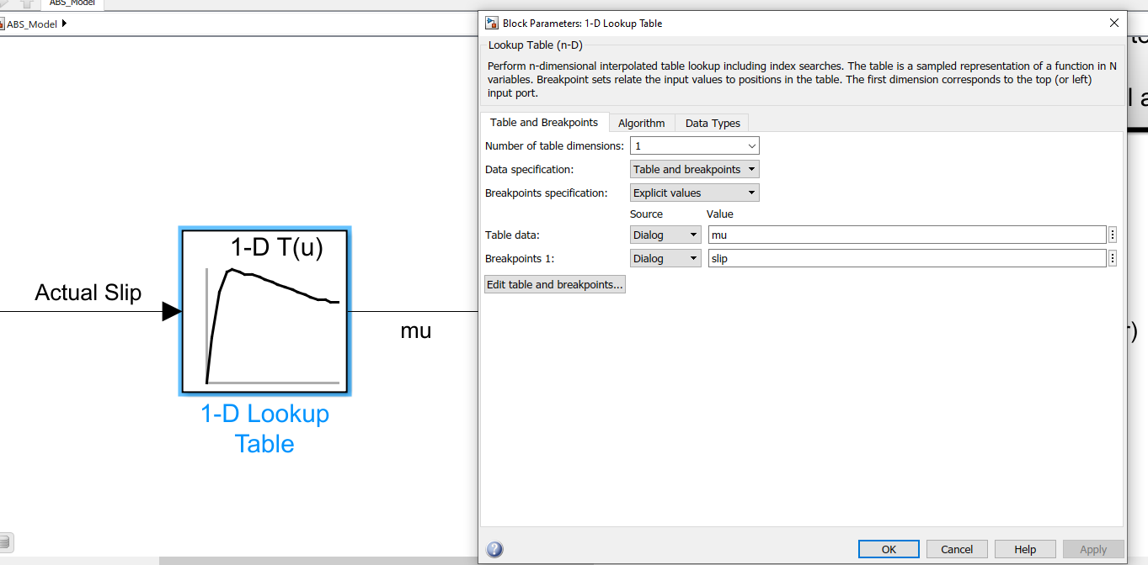

**Callbacks**

The table and breakpoint data for the 1D Look Up table are declared as variables in a script file (abs_data.m) and added as a callback in the model explorer. As a result, these variables are initialized in the base workspace when the model is opened, which is then used by the model.

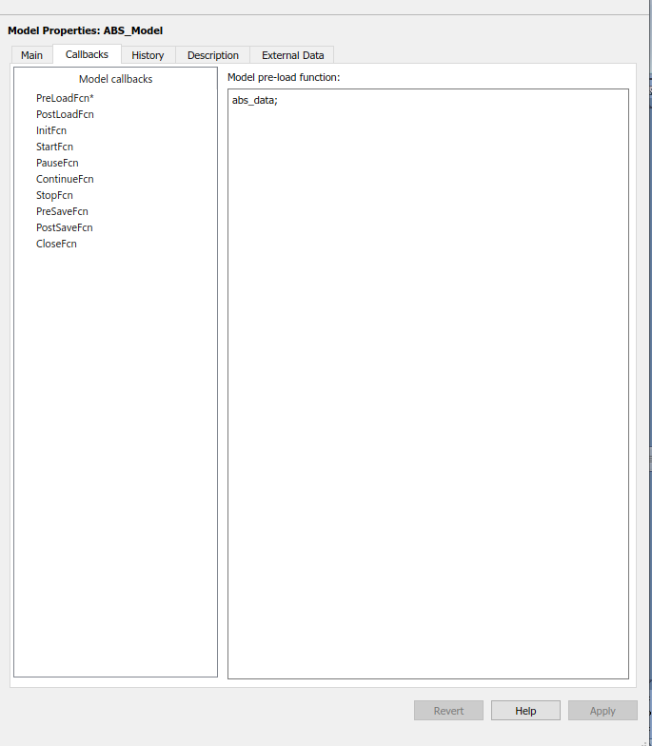

**MATLAB Function**

The slip value is dependent on wheel speed and vehicle speed. The difference between actual slip and desired slip, which is the error is provided as one of the inputs to wheelspeed referenced model. Inorder to calculate the slip from wheel speed and vehicle speed, a MATLAB function block is used.

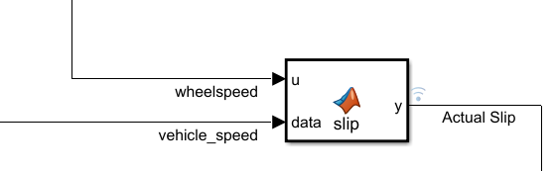

**Solver**

The solver chosen is a variable step continuous solver, ode45 (Dormand-Prince) with a maximum step size of 0.01. A variable step solver is needed to track the fast changes on the application of brakes. As the model uses continuous states, a continuous solver is also required.

**Data Inspector**

The simulation data inspector has been used to log the wheelspeed, vehicle speed and actual slip that the tyre suffers.

**Simulation Outputs**

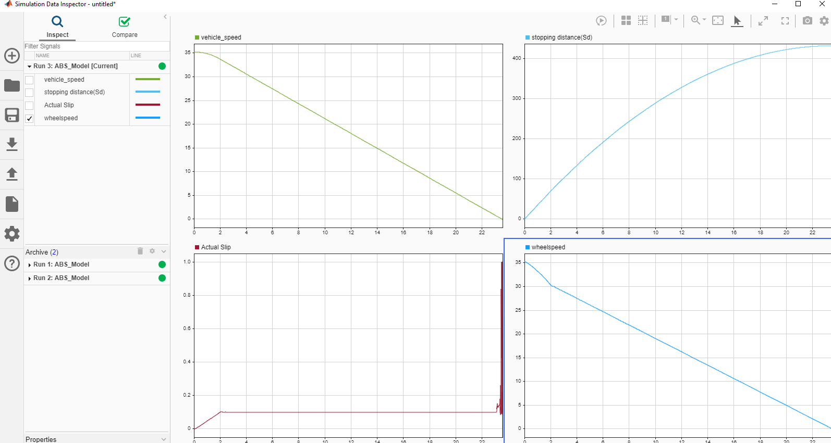

Figure: Desired Slip Value = 0.1

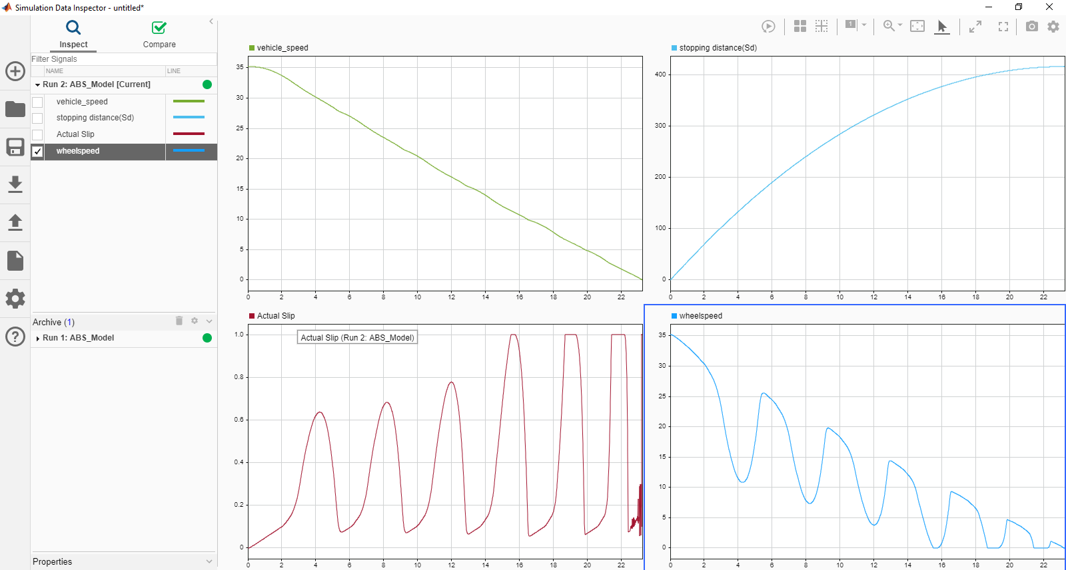

Figure: Desired Slip Value = 0.2

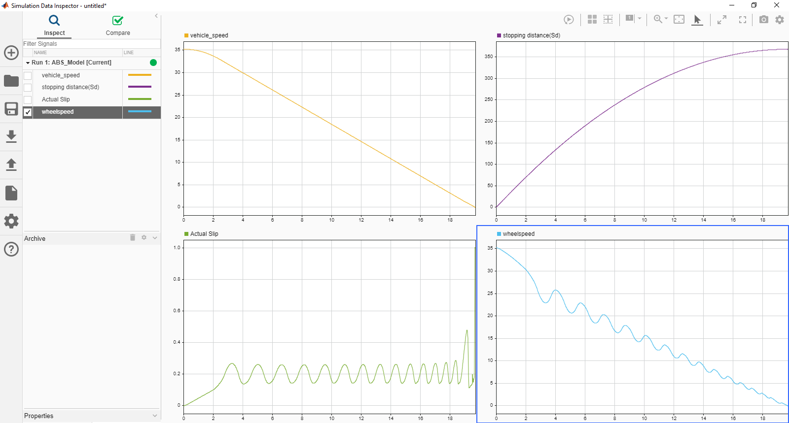

Figure: Desired Slip Value = 0.2